Types of Boosting Algorithm in Machine Learning

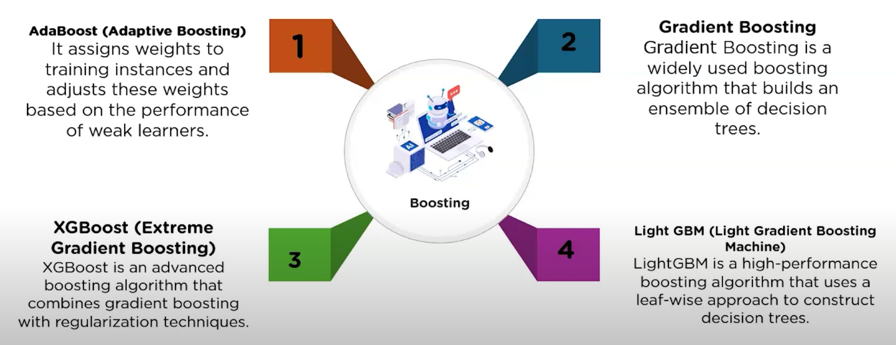

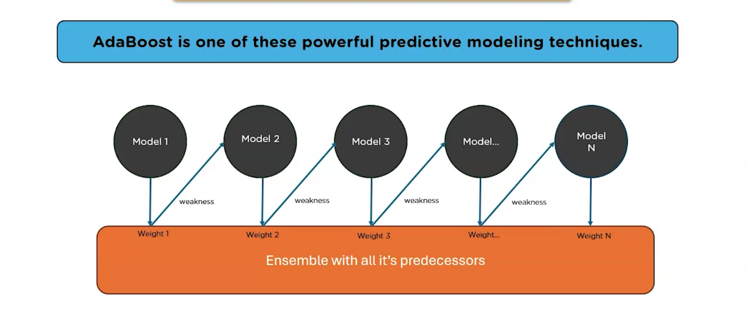
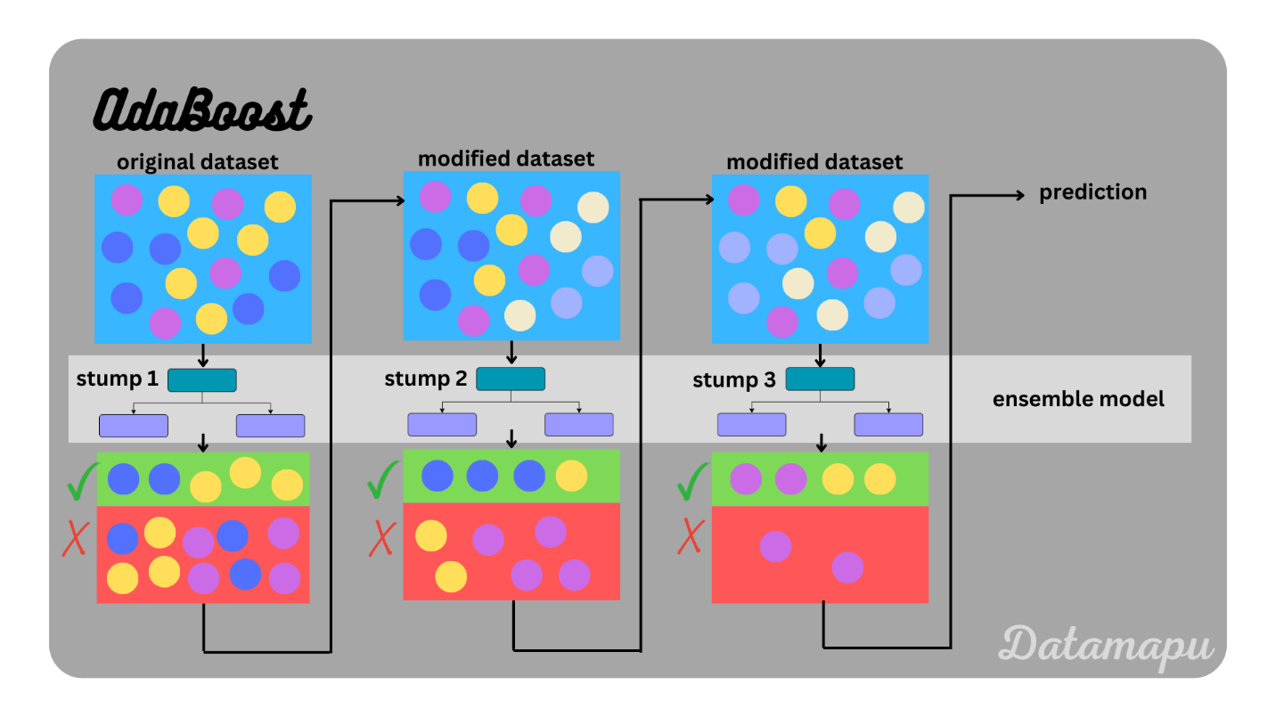

Gradient Boosting
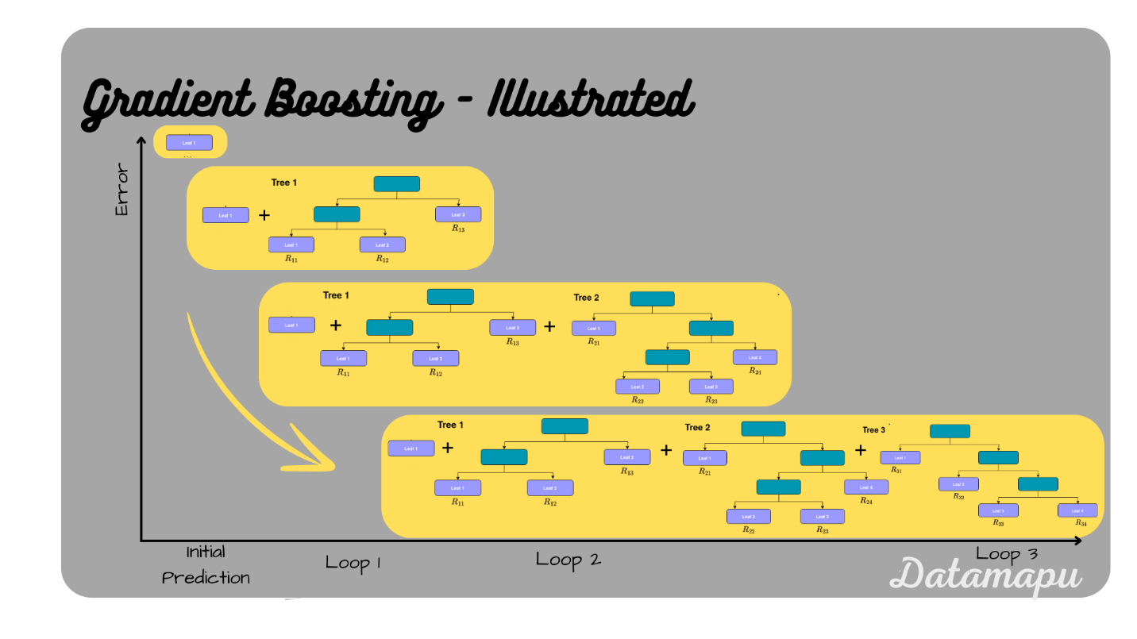

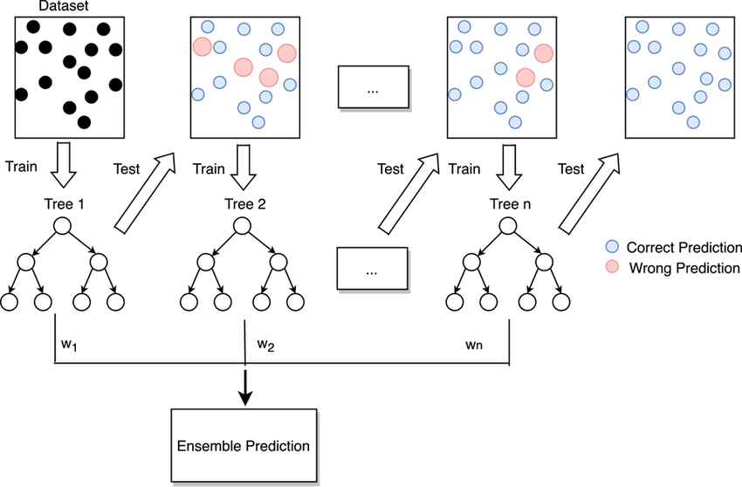

XGBoosting is nothing but eXtremeGradient Boosting algorithm
It is an advance model of Gradient Boosting algorithm

Light GBM - Leaf wise tree growth
